**Q)** Solve the grid using liebmann’s method ɛs =10%. Overrelaxation factor 1.5

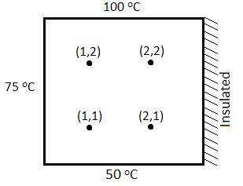

Tips to Converge fast:

* Start solving the grid from the corner (where the temperature is high) towards (insulated corner)
* Apply over relation only in first iteration.

|  |  |  |  |  |  |  |  |  |  |  |  |  |  |  |
| --- | --- | --- | --- | --- | --- | --- | --- | --- | --- | --- | --- | --- | --- | --- |
|  |  | **T12** | **T22** | **T32** | **T11** | **T21** | **T31** |  | **Ԑ T12** | **Ԑ T22** | **Ԑ T32** | **Ԑ T11** | **Ԑ T21** | **Ԑ T31** |
|  |  | 0.000 | 0.000 | 0.000 | 0.000 | 0.000 | 0.000 |  |  |  |  |  |  |  |
|  |  | 43.750 | 41.406 | 56.055 | 47.656 | 45.898 | 67.944 |  |  |  |  |  |  |  |
| **1st itr.** | **Over-**  **relax-**  **ation** | 65.625 | 62.109 | 84.082 | 71.484 | 68.848 | 101.917 |  |  |  |  |  |  |  |
| **2nd itr.** |  | 77.148 | 82.520 | 91.739 | 67.749 | 75.546 | 73.208 |  | 14.94 | 24.73 | 8.35 | -5.51 | 8.87 | -39.22 |
| **3rd itr.** |  | 81.317 | 87.151 | 86.877 | 70.466 | 70.206 | 69.322 |  | 5.13 | 5.31 | -5.60 | 3.86 | -7.61 | -5.60 |